READING
GROUP NOTES

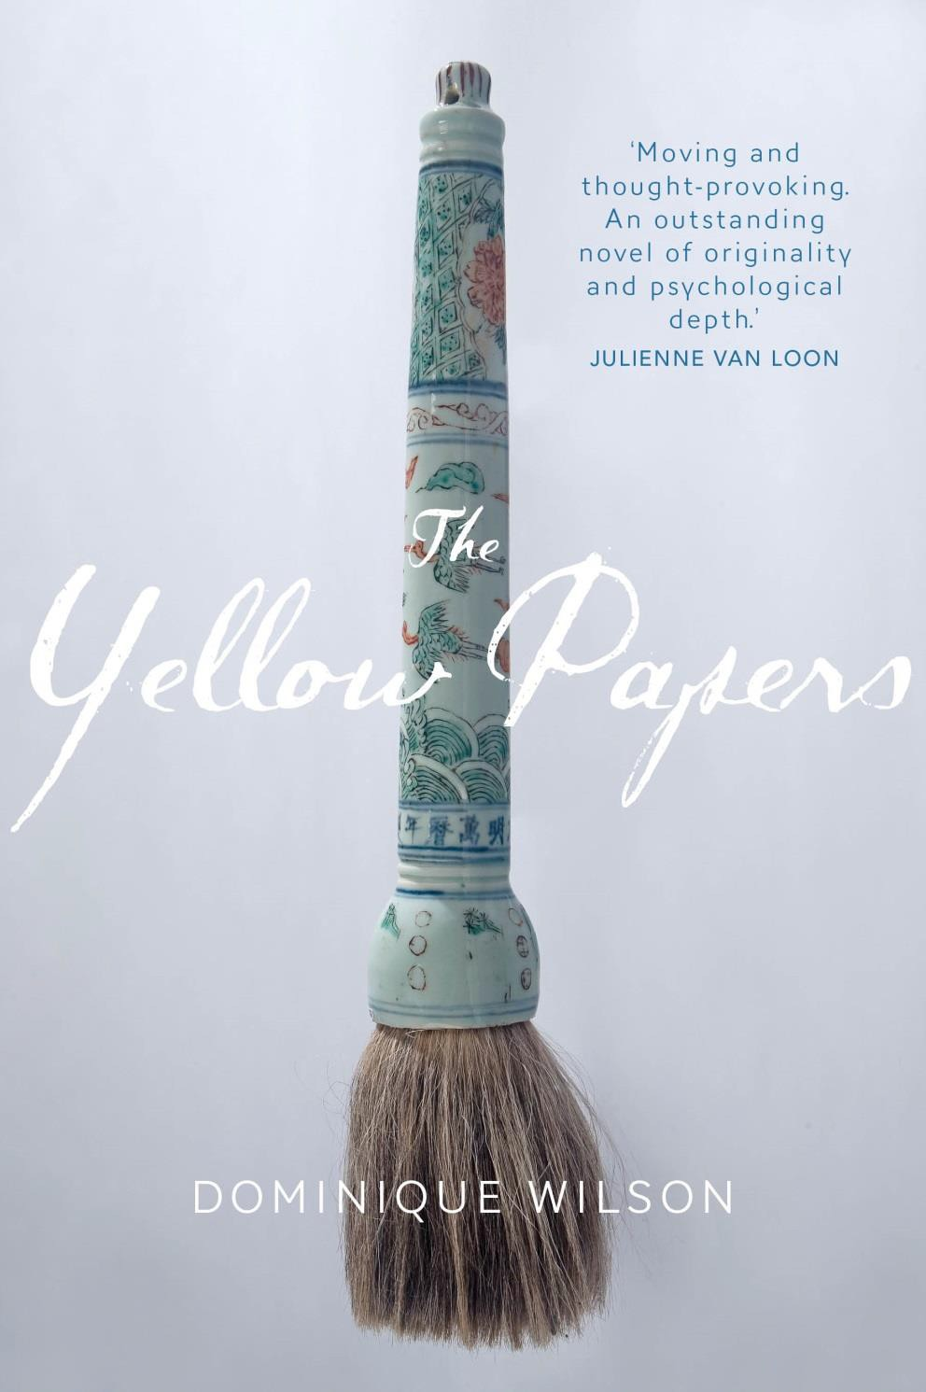

Contents: About the book; About the author; Reviews & Quotes, The author on writing the book; Suggested points for discussion; Suggested reading; Suggested viewing.

About the book

It's 1872 and China - still bruised from its defeat in the two Opium Wars - sends a group of boys, including seven-year-old Chen Mu, to America to study and bring back the secrets of the West. But nine years on Chen Mu becomes a fugitive and flees to Umberumberka, a mining town in outback Australia. He eventually finds peace working for Matthew Dawson, a rich pastoralist.

When the bubonic plague ravages Sydney, Matthew Dawson's daughter returns to her father's property with her son, Edward. But it's a lonely life for a small boy surrounded only by adults, and he soon befriends Chen Mu, forging a friendship that will last a lifetime.

Years later, Edward visits a mysterious and decadent Shanghai, where he falls in love with Ming Li, the beautiful young wife of a Chinese businessman, until invading Japanese armies tear the couple apart. Many years pass before the couple reunite, each scarred by the events of World War II and the Korean War. But will it be only to be torn apart once again?

The Yellow Papers is a story of love, obsession and friendship set against a backdrop of war and racial prejudice.

About the author

Dominique Wilson was born in Algiers to French parents. She grew up in a country torn by civil war, until she and her family fled to Australia.

Her short stories have been published nationally and read on ABC Radio, and one of her short stories was made into a short film. She was founding co-managing editor of Wet Ink: the magazine of new writing, and Chair of the Adelaide branch of International PEN. She holds a Masters and a PhD in Creative Writing.

For more information about Dominique Wilson, go to www.dominiquewilson.com.au

Reviews & Quotes

'Dominique Wilson is a wonderful storyteller. Spanning the histories of China and Australia, this tale, woven between tenderness and violence, percolates with alternating emotions until the final page is turned. The research is impeccable, the realism unforgiving.' Brian Castro, award-winning author of Shanghai Dancing and After China.

'While this attention to historical detail adds authenticity to the narrative, it is Wilson’s well-crafted characters and shrewd storytelling that arouse all the emotions that great tragedy is supposed to evoke... To compare The Yellow Papers to the historical
sagas of the kind that consistently rise to the tops of bestseller lists may seem to trivialise the importance of its subject matter, but the book will still satisfy a
readership hungry for a gripping, grandiose read.' Jennifer Peterson-Ward, Booksellers +
Publishers.

‘Moving and thought-provoking. An outstanding novel of originality and psychological
depth.’ Julienne van Loon, award-winning author of Road Story and Harmless.

'Dominique Wilson’s depiction of racial prejudice, torture and brutality is distressing and appalling, yet they are central to the narrative and they contrast with her exquisite rendering of the love at the heart of the story... I started this book ignorant of the historical events it depicts but finished it culturally enriched and enlightened.' Maureen Eppen, Good Reading Magazine.

'What stood out for me, and still does a week after reading it, is the way Wilson conveys the pain of war and racism – it’s honest, emotive, vivid and at times, raw. A recommended read for anyone who likes historical fiction and has a tendency to think over the issues raised for some time afterwards. A big thumbs up from me.' Monique Mulligan, The Blurb Magazine.

'What separates The Yellow Papers from the usual historical saga is partly the way Wilson redefines ‘family’ to include Chen Mu, and partly the way she respects the reader’s intelligence and leaves some gaps in the 90-year chronology that can be inferred without needing to labour the point... I was impressed by the uncompromising ending. The novel gathers tension towards the end, and the characters find themselves locked in a destructive pattern of relationships forged by
ideology rather than human behaviour. I can’t say more without spoilers, but this is a
novel that saves its biggest shock till the end.' Lisa Hill, ANZ LitLovers.

'Beautifully written from the first paragraph, the story of Chen Mu unfolds with all the delicacy of fine Chinese scroll work, designed to intrigue and enhance.' Janet Mawdesley, Blue Wolf Reviews.

The author, Dominique Wilson, on writing The
Yellow Papers

The original idea came about because of two Chinese women I know who both came to Australia at about the same age. One loved Australia from the very beginning. She eventually married an Australian and established herself as a successful business woman. The other – a tertiary student of mine – hated it and could see nothing good in this country. All she wanted to do was go back home, and she spent many-an-hour in my office in tears. This contrast interested me greatly, because it’s something I’ve seen again and again – people leaving everything behind, sometimes by choice, sometimes by circumstances, and having to cope with a totally new world, as it were. My own family was like that – we immigrated to Australia from Algeria when I was
ten, to escape a country that had been in the midst of civil war for seven years. Some of us quickly settled into this new life, but others – my mother, for instance – never did. So what is it that makes some people embrace a new country, and others reject it? I decided to explore this via fiction.

The Yellow Papers covers several decades, from just after the two Opium Wars to the time of the Cultural Revolution. And in between you have Sino-Japanese War, WWI, the Great Depression, the Second Sino-Japanese War, WWII and the Korean War. Can you imagine how many people would have been displaced through all that? How many would have fled to the cities, to the country? How many left loved ones behind? And of course, whenever you have displaced people, you have some
that will adapt and some that won’t. So I used this history almost as a character in its own right, in that it influences the actions of my four main characters. You have Chen Mu, sent to America when only a very small boy, only to flee to Australia years later. Edward, an Australian man with a romanticised idea of the East, who falls in love with Ming Li, the beautiful young wife of a Chinese business man. And you have Huang Ho, Ming Li’s grandson and a child of the Cultural Revolution. All four are carried on the wings of history, as it were, and how they adapt is what decides their destiny…

It took me about two-and-a-half years all up to research and write to a first draft standard. I started the research with a broad focus, narrowing it down to finer and finer details as the plot took shape – if you imagine a funnel, starting off broad and narrowing down, you’ll have an image of my research method. I used all sorts of things to build in my mind a picture of China at that time – books (both fiction and nonfiction, written both by Westerners and Chinese), documentaries, films, academic papers, diaries. I also spoke to a lot of people who had lived there during the latter time of my novel. But what I found invaluable was all the film footage, available on YouTube, taken by film enthusiasts of the time – tourist film, if you will, and
newsreels as well. To be able to stop film footage taken of the backstreets of
Shanghai in the 1920s, for example, and examine every detail – priceless!

I think my own background – growing up in Algieria and moving to Australia as a child – greatly influenced my writing. We fled a country that had been in the midst of civil war for seven years, so I still have vivid memories of what that was like. And also how it felt to arrive in a country I knew nothing about, whose language I couldn’t speak, and whose traditions, food, ideas and so on were very different to what I
knew. When it came to putting my characters in similar situations, I was able to draw on some of these memories.

For discussion

The colour yellow is not only in the title, but used subtly as a symbol throughout the book. Consider when this is used. Why do you think the author chose this particular colour? To what could she have been referring?

Discuss the symbolism of the jade brush-rest and how this is used throughout the book.

Consider Chen Mu in comparison to Edward. Discuss the similarities and differences between the two men. What could they learn from each other?

Discuss Edward’s relationship with the women in his life - his wife, daughter, mistress. How much influence do you think his war experiences have on his attitude towards them?

Discuss the different ways in which Ming Li deals with her circumstances. Do you see her as strong, or weak?

Chen Mu, Sahira, Huang Ho and even Ming Li can all be considered 'outsiders', whilst Edward is an 'insider'. In what ways is the idea of home and country important to the characters of The Yellow Papers, and how do these ideas differ or share similarities? Discuss.

Each of the main characters have suffered as a result of political events. How do their sense of culture and identity help them begin to heal these wounds?

Are safety and security just illusions?

What is the role of memory for each of the characters? Particularly consider its significance for Chen Mu, Edward, Ming Li and Huang Ho.

Maureen Eppen, in her review in Good Reading Magazine, states that
'Dominique Wilson’s depiction of racial prejudice, torture and brutality is distressing
and appalling, yet they are central to the narrative...' Do you agree?

Each relationship in this novel involves a certain level of dishonesty. Discuss.

Yearning for love is a central theme of The Yellow Papers. Discuss the different ways each of the main characters seek love. Which do you think is most effective?

Death is also a central theme. Discuss each of the main character's reaction to it.

Fate and destiny are major themes in this story. Could any of the characters have escaped their destiny? How/when?

The Yellow Papers raises many confronting and complex issues, yet the writing style is simple. Do you think this is deliberate? What effect does it have?

The ending of The Yellow Papers has been described as surprising. Did you find it so? Why? Could it have ended any other way?

In reading and discussing this book with your group, did you change your mind about your initial opinion of war, conflict and displacement? Discuss your answers to this question within the greater framework of the importance of literature.

Suggested reading

Exile: The Lives and Hopes of Werner Pelz - Roger Averill [2012]

Iran: My Grandfather - Ali Alizadeh [2010] Shanghai Dancing - Brian Castro [2009] The New Angel - Ali Alizadeh [2008]
A History of the Great War: A Novel - Peter McConnell [2007]

Snow Flower and the Secret Fan - Lisa See [2006]

The Kitchen God's Wife - Amy Tan [2006]

The Good Earth - Pearl S. Buck [2005]

Wild Swans: Three Daughters of China - Jung Chang [2003]

Balzac and the Little Chinese Seamstress - Sijie Dai, Ina Rilke (Translator) [2002] When Heaven and Earth Changed Places: A Vietnamese Woman's Journey from War to Peace - Le Ly Hayslip, Jay Wurts[1993]

Suggested viewing

Legendary Sin Cities - Paris, Berlin & Shanghai [documentary, 2005]

The Blue Kite [1993]

Farewell My Concubine [1993]

The Red Violin [1988]

The Yellow Papers Dominique Wilson Transit Lounge Publishing
Trade paperback - ISBN: 9781921924613
These Reading Notes may be printed or viewed for your own private, non-commercial use.
This material is copyright and may not be repackaged, resold or posted electronically on any network without prior written permission from Transit Lounge Publishing

Transit Lounge Publishing
95 Stephen St Yarraville Victoria 3013
Australia

www.transitlounge.com.au

info@transitlounge.com.au

© 2014 Transit Lounge Australia

